**Total HealthCare – Clinic Website**

**INTEGRATED PROJECT REPORT**

**SUBMITTED BY**

|  |  |
| --- | --- |
| Name of Student(s) | University Roll No. |
| Sarthak Jain | 1611981339 |
| Nitish Sharma | 1611981262 |
| Gokul Katoch | 1611981148 |

**SUPERVISED BY**

Mr. Naveen Kalra

Satshri Technologies

April 2017



**CHITKARA UNIVERSITY, HIMACHAL PRADESH**

**CERTIFICATE**

I hereby certify that the work which is being presented here in the Project Report entitled **“Total HealthCare – Clinic Website”,** is an authentic record of my own work carried out during a period **from January 2017 to April 2017 (2nd semester)** under the supervision of (**Mr. Naveen Kalra, Satshri Tech**).

**Signature of Student(s)**

Sarthak Jain (161981339), Nitish Sharma (1611981262), Gokul Katoch (1611981148)

Date: Place:

This is to certify that the above statement made by the student(s) is correct to the best of my

knowledge.

**Signature of Supervisor**

**Mr. Naveen Kalra, Satshri Tech.**

**ACKNOWLEDGEMENT**

We have taken efforts in this project. However, it would not have been possible without the kind support and help of many individuals and organizations. We would like to extend my sincere thanks to all of them.

We are highly indebted to Mr. Naveen Kalra for his guidance and constant supervision as well as for providing necessary information regarding the project & also for his support in completing the project.

Our thanks and appreciations also go to our colleagues who helped us in finishing the project and to the people who have willingly helped us out with their abilities.

**Date: Place:**

Sarthak Jain (1611981339)

Nitish Sharma (1611981262)

Gokul Katoch (1611981148)

**TABLE OF CONTENTS**

Page No.

Certificate..........................................................................................................2

Acknowledgement.............................................................................................3

List of Tables……………………………………………….…………………5

Abstract.............................................................................................................6

**Chapter 1: INTRODUCTION.......................................................................8**

**Chapter 2: LITERATURE SURVEY.........................................................13**

**Chapter 3: METHODOLOGY....................................................................16**

**Chapter 4: RESULTS AND DISCUSSION................................................17**

**Chapter 5: CONCLUSION AND FUTURE SCOPE.................................18**

Some Screenshots……………………………………………………………21

References........................................................................................................26

**LIST OF TABLES**

Table 1 : Tags used in project………..…………………..……………….7

Table 2 : Software Requirements…..……………………………………10

Table 3 : Definitions of Key Design Elements…...……………………...14

**ABSTRACT**

We have made a full-fledged, near-professional, Clinic Website in which we have included all the needed and important functions that are needed for Clinic Management. We have accomplished all this using various languages such as **HTML, PHP, JavaScript, JQuery, MySQL and CSS**. Our website is dynamic in nature and not static. All tabs and links which are required for this particular website are properly linked and all are working as per their requirement. In our website we have also included a completely working Appointment Booking System, by the help of which a patient can book his/her appointment with the Department needed and the date of his/her choice which is done with the help of PHP & MySQL. Everything that has been written in the code is in our knowledge and we know about each tag as listed in Table 1.

**Table 1: Tags used in project**

|  |  |
| --- | --- |
| **Tag** | **Description** |
| * [**<!DOCTYPE>**](https://www.w3schools.com/TAgs/tag_doctype.asp) | Defines the document type |
| * [**<a>**](https://www.w3schools.com/TAgs/tag_a.asp) | Defines a hyperlink |
| * [**<body>**](https://www.w3schools.com/TAgs/tag_body.asp) | Defines the document of the body |
| * [**<br>**](https://www.w3schools.com/TAgs/tag_br.asp) | Defines a single line break |
| * [**<button>**](https://www.w3schools.com/TAgs/tag_button.asp) | Defines a clickable button |
| * [**<div>**](https://www.w3schools.com/TAgs/tag_div.asp) | Defines a section in a document |
| * [**<h1> to <h6>**](https://www.w3schools.com/TAgs/tag_hn.asp) | Defines html headings |
| * **<img>** | Defines an image |
| * [**<head>**](https://www.w3schools.com/TAgs/tag_head.asp) | Defines information about the document |
| * [**<li>**](https://www.w3schools.com/TAgs/tag_li.asp) | Defines a list item |
| * **<p>** | Defines a paragraph |
| * **<style>** | Defines style information for a document |

With the help of these tags we were able to make our website make more effective and appealing to the eyes.

**CHAPTER – 1**

**INTRODUCTION**

In our Project, Total HealthCare, we have included a system for the Registration of Patients and storing their details into the system. There’s also a separate Admin Panel for Doctors, where Doctors can check the appointments that have been made. There’s also a facility to store the details of every patient automatically. It includes a registration facility to book patient’s appointment in any of the offered departments.

The Doctor’s Admin Panel System can be accessed using some pre-programmed Email ID(s) and Password(s). This panel is made to be only accessed by a Doctor.

The following Email ID(s) & Password(s) can be used to access the Admin Panel

Email ID **–** [**doctor1@gmail.com**](mailto:doctor1@gmail.com) Password **–** ‘password’

Email ID – [**doctor2@gmail.com**](mailto:doctor2@gmail.com) Password – ‘password’

Only they can access Patient data from the Database. The data can be retrieved easily. The interface is very user-friendly.

The system behind Total HealthCare website is powerful, flexible, and easy to use and is designed and developed to deliver real conceivable benefits to hospitals. Total Healthcare System is designed for multispecialty hospitals, to cover a wide range of clinics, hospital administration and management processes.

It is an integrated end-to-end Total Healthcare System that provides relevant information across the hospital to support effective decision making for patient care, clinic administration and the necessary information required to patient before coming into the clinic.

Clinic/Hospital Management System is a software product suite designed to improve the quality and management of hospital management in the areas of clinical process analysis and activity-based costing. Total Healthcare System enables you to develop your organization and improve its effectiveness and quality of work. Managing the key processes efficiently is critical to the success of the hospital helps you manage your processes.

**SOFTWARE REQUIREMENTS**

Software requirement deals with defining software resource requirements and pre-requisites that need to be installed on a computer to provide optimal functioning of an application. These requirements or pre-requisites are generally not included in the software installation package and need to be installed separately before the software is installed.

For this particular website, the software requirements are given in Table 2 below :-

**Table 2 : Software Requirements**

|  |  |
| --- | --- |
| Operating System Needed | Windows XP - 10 |
| Front End | A Browser that supports HTML5, CSS and JavaScript/JQuery |
| Server Side Script | PHP |
| Database | MySQL |
| Software Package used for PHP & MySQL | Wampserver |

A brief description of the Languages & scripts used in our project is given on the next page :-

**LANGUAGES AND SCRIPT INVOLVED IN THE PROJECT**

**HTML (Hypertext Mark-up Language) :-**

It is the standard mark-up language used to create web pages. HTML is written in the form of HTML elements consisting of tags enclosed in angle brackets (like <html>). HTML tags most commonly come in pairs like <h1> and </h1>, although some tags represent empty elements and so are unpaired, for example <img>. The purpose of web browsers is to read HTML documents and compose them into visible or audible web pages. The browser does not display the HTML tags, but uses the tags to interpret the content of the page. HTML elements form the building blocks of all websites. HTML allows images and objects to be embedded and can be used to create interactive forms.  It can embed scripts written in languages such as JavaScript which affect the behaviour of HTML web pages.

**CSS (CASCADING STYLE SHEETS) :-**

It is a style sheet language used for describing the appearance and formatting of a document written in a mark-up language.CSS is designed primarily to enable the separation of document content from document presentation, including elements such as the layout, colours, and fonts. While most of the style of the webpages and interfaces written in HTML, CSS is a corner stone specification of the web and almost all webpages use CSS style sheets to describe their presentation. This separation can improve content accessibility, provide more flexibility and control in the specification of presentation characteristics, enable multiple pages to share formatting, and reduce complexity and repetition in the structural content. It can also be used to allow the web page to display differently depending on the screen size or device on which it is being viewed.

**.**

**MySQL :-**

is developed, distributed, and supported by Oracle Corporation. MySQL is a database system used on the web it runs on a server. MySQL is ideal for both small and large applications. It is very fast, reliable, and easy to use. MySQL can be compiled on a number of platforms. The data in MySQL is stored in tables. A table is a collection of related data, and it consists of columns and rows. Databases are useful when storing information categorically.

**JavaScript :-**

It is the scripting language for the Websites. All modern HTML pages are using JavaScript. JavaScript is a lightweight scripting and programming language. JavaScript code can be inserted into any HTML page, and it can be executed by all types of web browsers. JavaScript is easy to learn.

**PHP (Hypertext Pre-Processor) :-**

It was earlier known as **Personal Home Page**. It is a widely-used, open source scripting language. PHP scripts are executed on the server. PHP files can contain text, HTML, CSS, JavaScript, and PHP code. PHP files have extension ‘.php’.

PHP is compatible with almost all servers used today. It supports a wide range of databases. PHP is free. Download it from the official PHP resource: www.php.net.com.

**CHAPTER – 2**

**LITERATURE SURVEY**

Proper design has become a critical element needed to engage a user in a website. Little research has been conducted to define the specific elements used in effective website. We attempt to review and consolidate research on effective design and to define a short list of elements frequently used in research. The design elements mentioned most frequently in the reviewed literature were navigation, graphical representation, organization, content utility, purpose, simplicity, and readability. We discuss how previous studies define and evaluate these seven elements. This review and the resulting short list of design elements may be used to help designers and researchers to operationalize best practices for facilitating and predicting user engagement.

Internet usage has increased tremendously and rapidly in the past decade. Websites have become the most important public communication portal. Poorly designed websites may frustrate users. On the other hand, a well-designed website with high usability has been found to positively influence visitor retention. However, there are no clear guidelines that individuals can follow when designing websites to increase engagement.

In defining and operationalizing each of these elements, the research studies suggested that effective navigation is the presence of salient and consistent menu/navigation bars, aids for navigation (e.g., visible links), search features, and easy access to pages. These elements are listed in table 3.

**Table 3 : Definitions of Key Design Elements**

|  |  |
| --- | --- |
| **Key Elements** | **Definition** |
| Navigation | • Consistency of navigation bar  • Aids for navigation (e.g., visible links)  • Easy access to web pages  • Search features  • Users feel in control/ease of managing |
| Graphical Representation | • Inclusion of images  • Size and resolution of images  • Multimedia content (e.g., animation or audio)  • Colour, font, and size of text  • Distinct logos and icons  • Visual attractiveness/layout  • Colour schemes  • Effective use of white space/avoid visual overload  • Minimizing loading time for visual elements |
| Organization | Cognitive mapping/architecture  • Understandable structure  • Logical organization |
| Readability | • Easy to read  • Well-written  • Grammatically correct  • Understandable  • Appropriate amount of content on each page/readable blocks  • Reading level appropriate content |

With all these website learning elements we also study about our topic “Total Healthcare Website” which includes hospital logo, services, hospital timings and many more. We write all about these from our own knowledge and from internet also.

**CHAPTER – 3**

**METHODOLOGY**

Hospitals currently use a manual system for the management and maintenance of critical information. The current system requires numerous paper forms, with data stores spread throughout the hospital management infrastructure. Often information is incomplete or does not follow management standards. Forms are often lost in transit between departments requiring a comprehensive auditing process to ensure that no vital information is lost. Multiple copies of the same information exist in the hospital and may lead to inconsistencies in data in various data stores.

The Total HealthCare Management System is designed for any hospital to replace their existing manual paper based system. The new system is to control the information of patients. Room availability, staff and operating room schedules and patient invoices. These services are to be provided in an efficient, cost effective manner, with the goal of reducing the time and resources currently required for such tasks.

**CHAPTER – 4**

**RESULT AND DISCUSSION**

The project “Total Healthcare System” is aimed to maintain the day-to-day state of admission/discharge process, list of doctors etc. It is designed to achieve the following objectives :-

* Define the Clinic.
* Giving all the needed information to the patient regarding all the services offered and information to contact the Clinic Staff.
* Recording information about the patients that come.

We have used HTML language to make the home page and all of its frontend and used CSS for its styling. We have defined our hospital and have made the login page of doctors so that they may be able to see the appointments of patients and have used MySQL Database for storing the information into the database. PHP acts as a script that connects the web page to the Database.

**CHAPTER – 5**

**CONCLUSION AND FUTURE SCOPE**

The proposed software is the Total HealthCare Clinic Management System.

This system can be used in any Hospital or Clinic to get the information about the patients and then storing that data for future usage.

Currently, the most-widely used system is a paper based system. It is too slow and cannot provide updated lists of patients within a reasonable time frame.

The intention of our system is to reduce the work load of the management staff and increase the efficiency of the management, which in result, will increase number of patients that can be treated accurately.

With further knowledge of computer languages, we can extend this website to a larger scope with more things included in it which are listed in the table below :-

|  |
| --- |
| A mechanism in which Bills are generated automatically by recording the price for each facility provided to Patient on a separate sheet and at last they all are summed up and a final Bill is generated for the Patient. |
| A system with the help of which, Immunization records of children can be maintained in pre-formatted sheets, which are kept in a file. |
| A system which automatically sends an SMS to the patient if a doctor approves, postpones or prepones his/her appointment. |
| Information about various diseases is not kept as any document. Doctors themselves do this job by remembering various medicines. We can also link it to a database having information about the various medicines used for various medical treatments. |
| When a doctor is on leave, he/she can apply the duty leave from this software and further hospital is able to cancel all the appointments of that doctor. |
| Information about the staff salary, fees given by patient and total income of the hospital must be stored in system. |

All this work is done manually by the Receptionist and other operational staff and lot of papers are needed to be handled and taken care of. Doctors have to remember various medicines available for diagnosis and sometimes miss better alternatives as they can’t remember them at that time.

Some of the problems that we encountered during the making of the project and solution to that is given by :-

Another difficult task was to connect the website with some database to let it able to store and see the appointments of patients. We had to link the MySQL Databases for the Patient’s Appointments and the Doctor’s Login details with their Front-ends. This was accomplished by looking at some of the already-working similar systems and studying the various languages and their Syntaxes. We used PHP to connect our website to the database.

We were not able to implement some features in the website in the start, like the Doctor’s Login Page and the Back Panel for the Doctor. This was achieved by studying some examples and taking help from sir **Mr. Naveen Kalra**, who helped us a lot!

The whole systems activities are divided into three major parts like patients, doctors, and admin. Each one has their own role to perform and system respond accordingly. For implementing the system, tools like PHP, JavaScript, jQuery, MySQL, CSS are used. Current Dialog patient conversation and News part are dynamic and it is a part of Content Management System (CMS). Some parts used CMS concept and works exactly like them.

**SOME SCREENSHOTS OF THE WEBSITE**

The Home Page



The Appointment Booking Panel

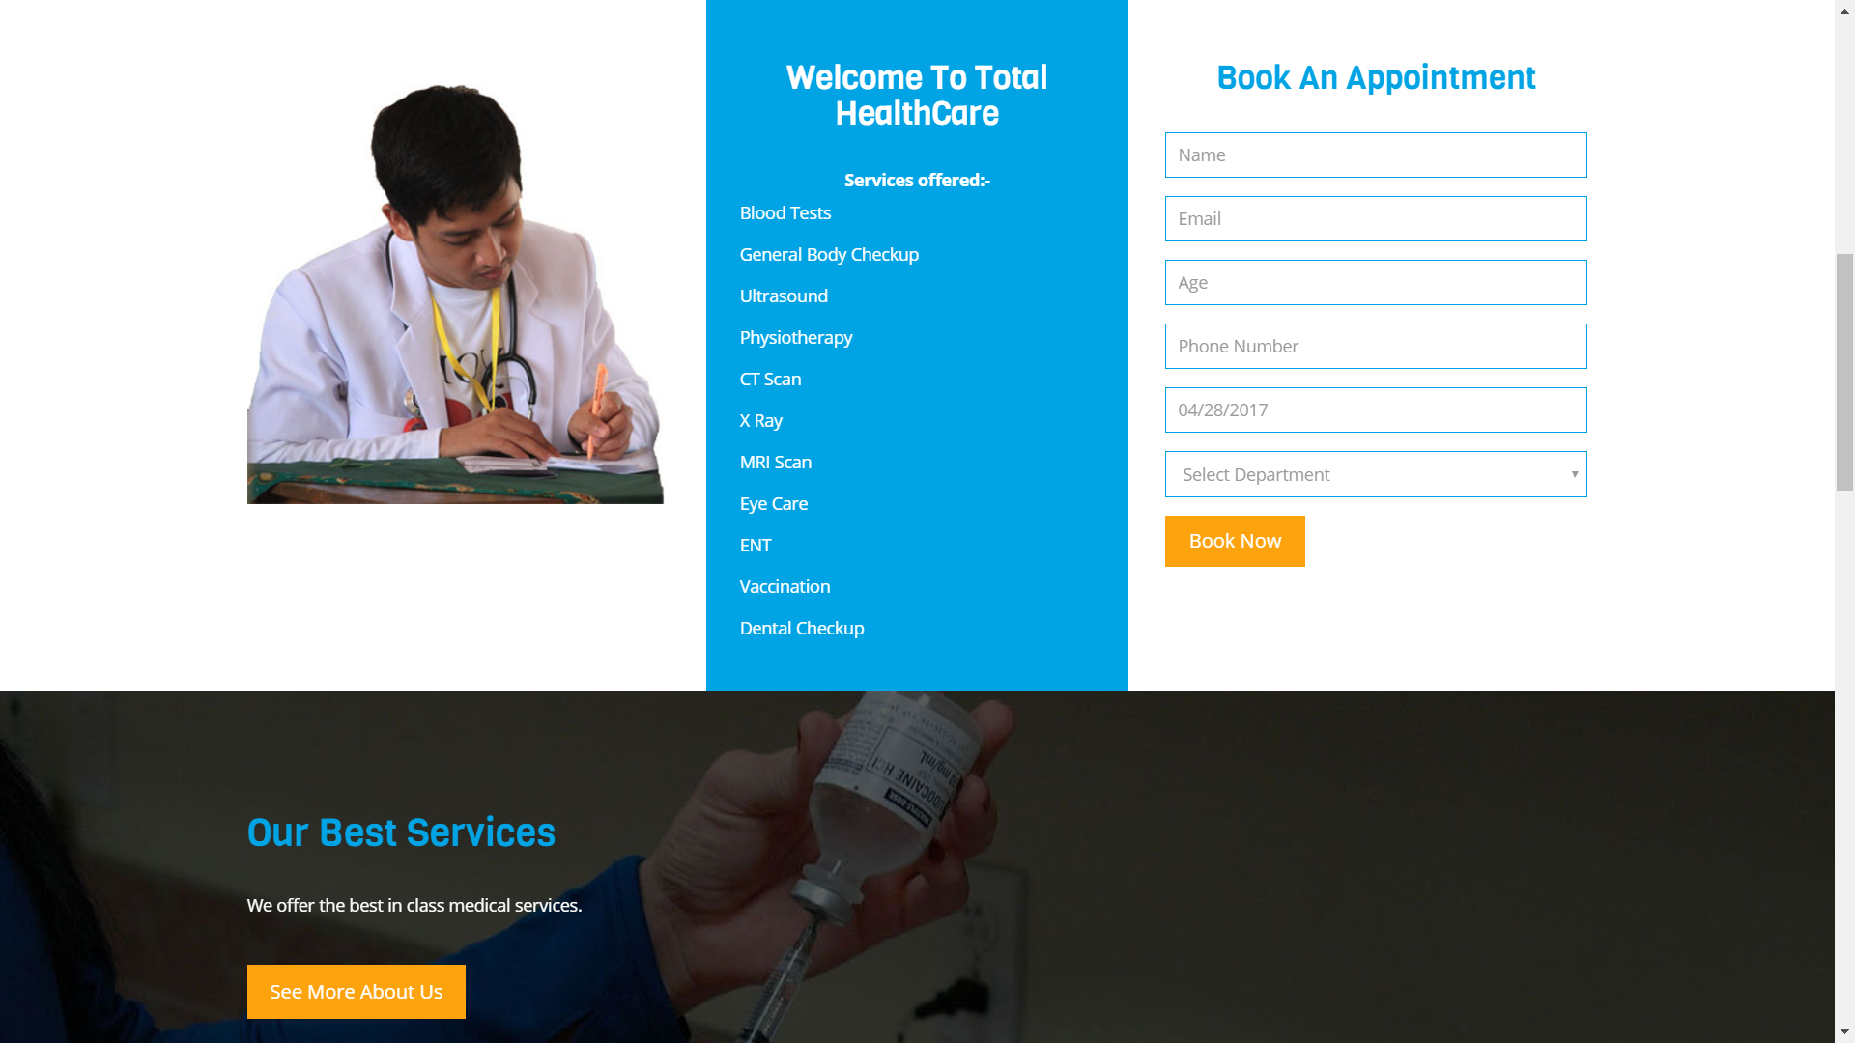

The Doctor Login Panel

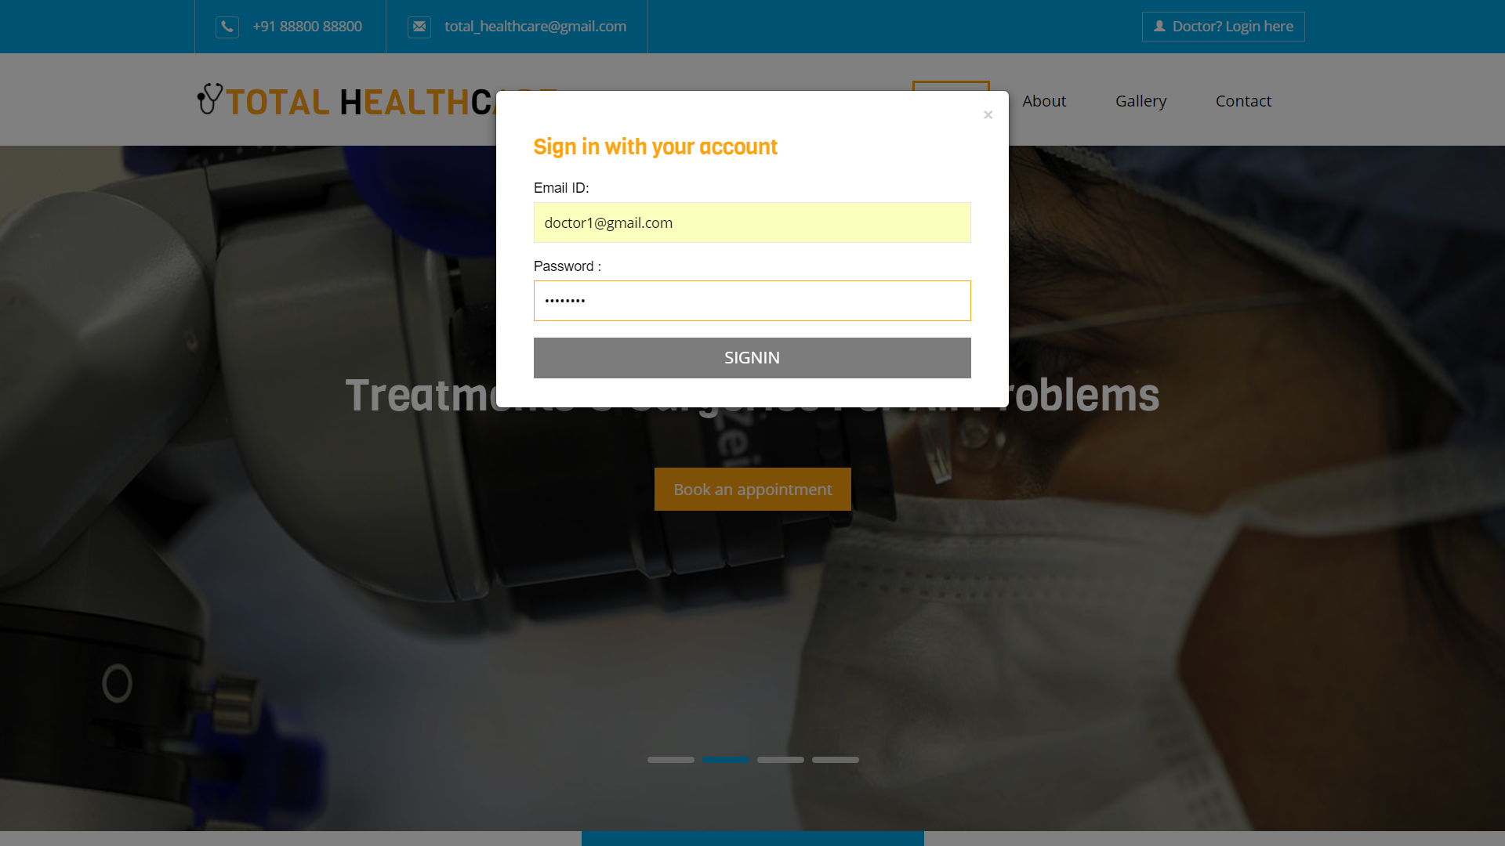

The Doctor’s Admin Panel

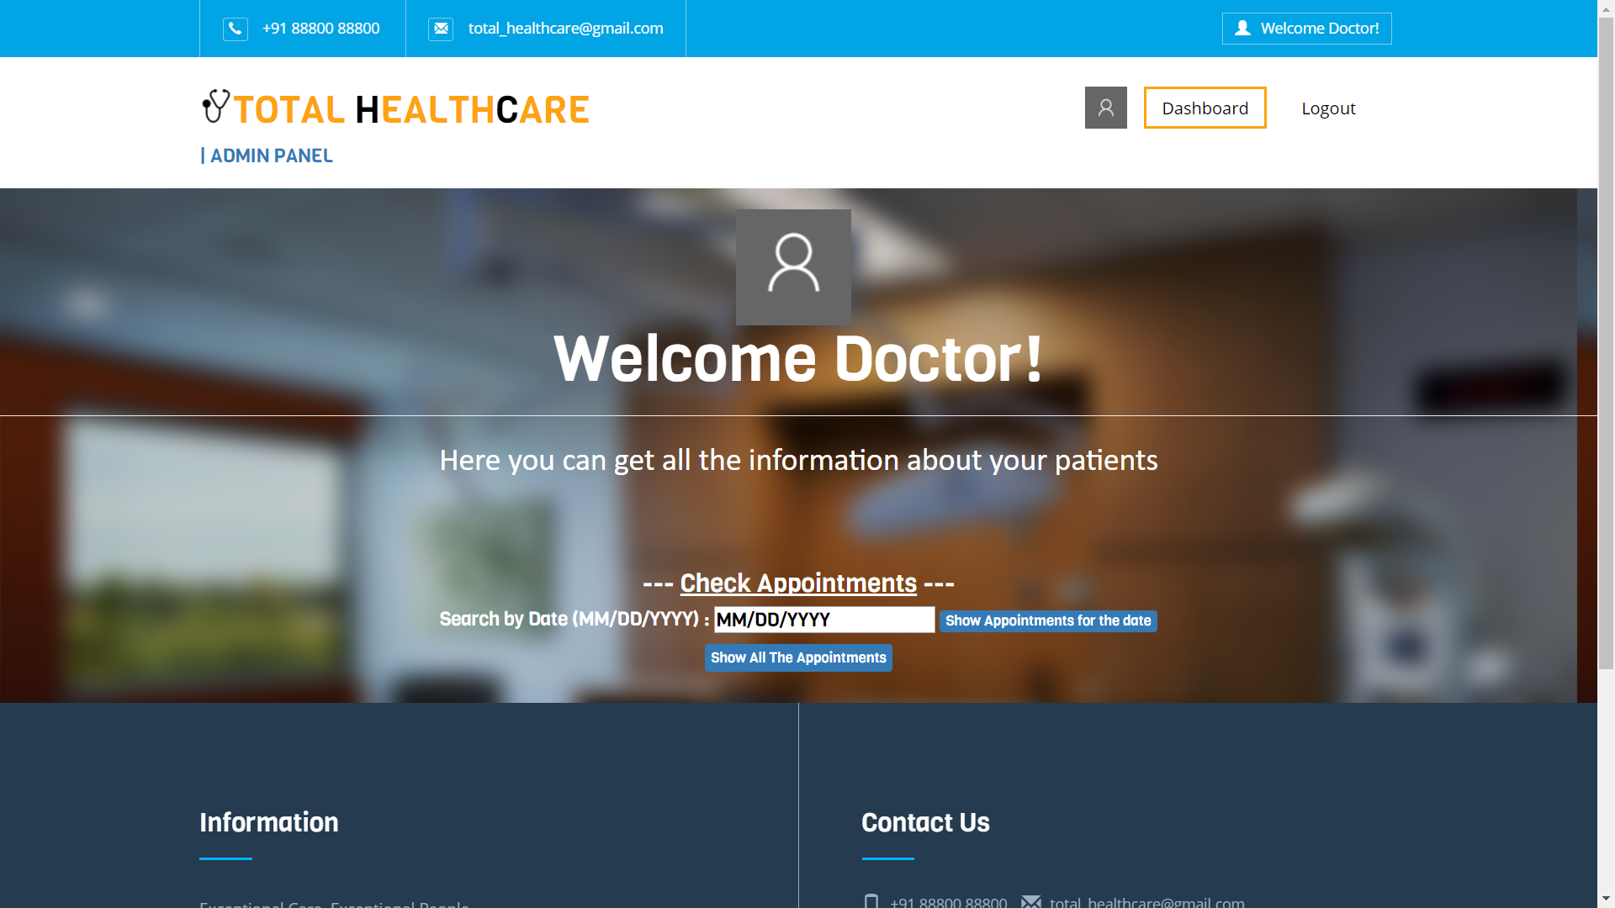

An example of the Appointment Record(s)

that are shown to the Doctor on the Admin Panel

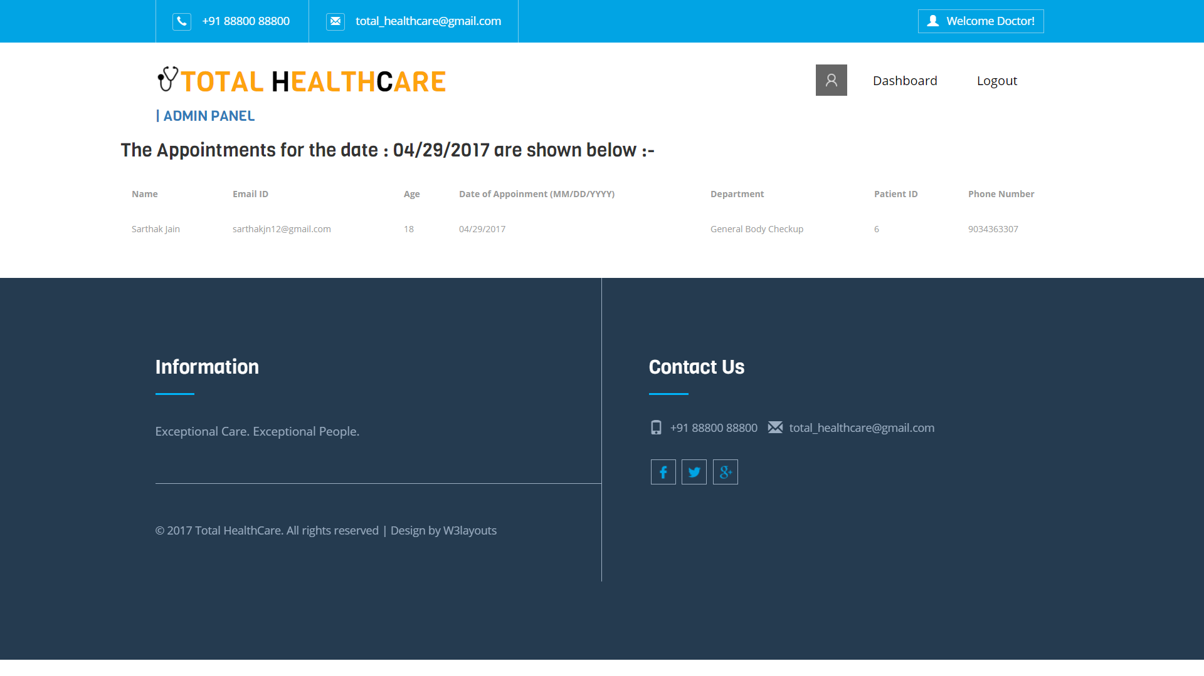

**REFERENCES**

We took help from the following sites:-

www.google.com

[www.w3schools.com](http://www.w3schools.com)

[www.youtube.com](http://www.youtube.com)

[www.tutorialspoint.com/php7](http://www.tutorialspoint.com/php7)

<https://html5forwebdesigners.com/>